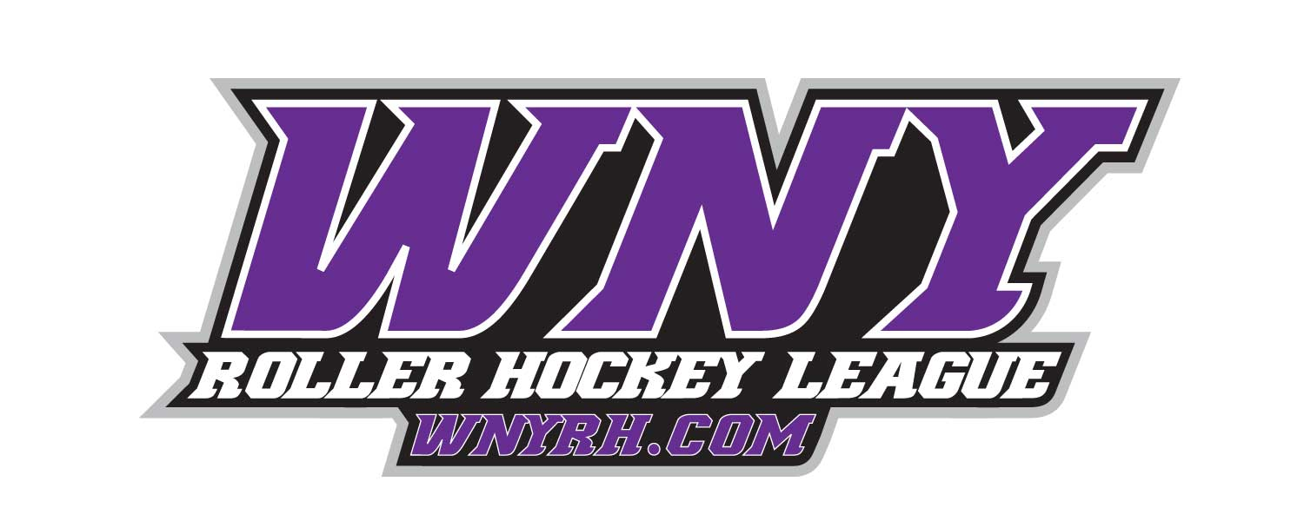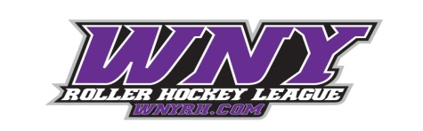

***Guaranteed 3 Games***

***_____________________________________________________________________________________________________***

**@ The Kenan Center Arena**

**December 22nd – 23rd 2018**

* Awards for High Scorer, Top Goalie, & MVP

* Adult Aluminum, Adult Iron, Adult Copper, & Adult Bronze Divisions.

* **$375 per team** *(Register Early for Discounts)*

* Prizes for 1st & 2nd place Teams.

* For more Info on registering call Jason at 716-444-2667 or email Eric@wnyrh.com.

**Holiday Cup 2018**

WNYRH.COM