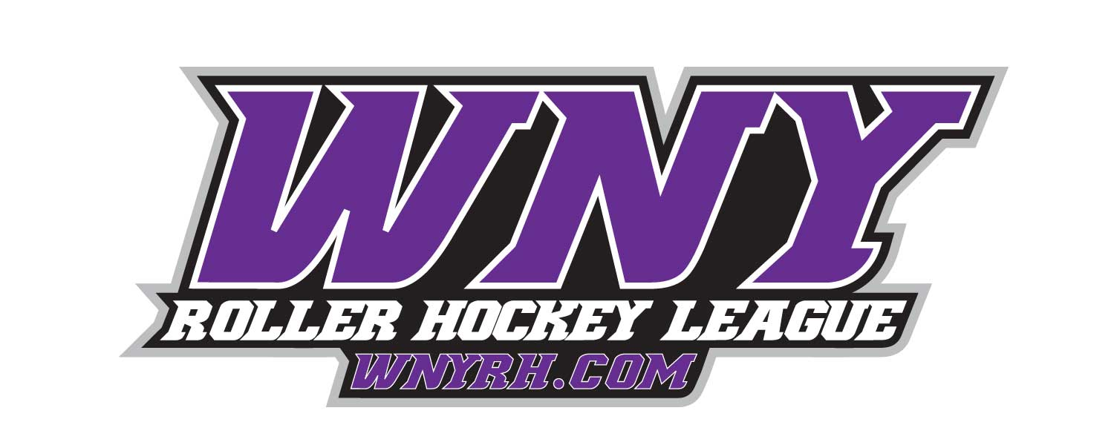

• Awards for 1st & 2nd Place teams

• Awards for League MVP, Top Goalie and Championship MVP

• Player of the Month Awards in each Division

**DIVISIONS:**

**Wednesday**—Adult Tin, Aluminum, Iron, Copper, Bronze, & Silver

**Thursday**-Adult Tin, Aluminum, Iron, Copper, Bronze, & Silver

**Friday**— Adult Aluminum, Iron, & Copper

**\*Payment\***

**$100 Deposit required at time of registration**

**$90** per skater if your roster size is 8 or 9 players

**$100** per skater if your roster size is 7 players

**$115** per skater if your roster size is 6 players

**Goaltenders**—**$50** (can play on multiple teams with in division)

• **For more info on registering your team please contact Jason at 444-2667 or email eric@wnyrh.com**

***8 Game Session! (Space is Extremely Limited!)***

_________________________________________________________________________

**@ WNY Sports Arena**

**Fall Session Begins Oct 9th 2019**