
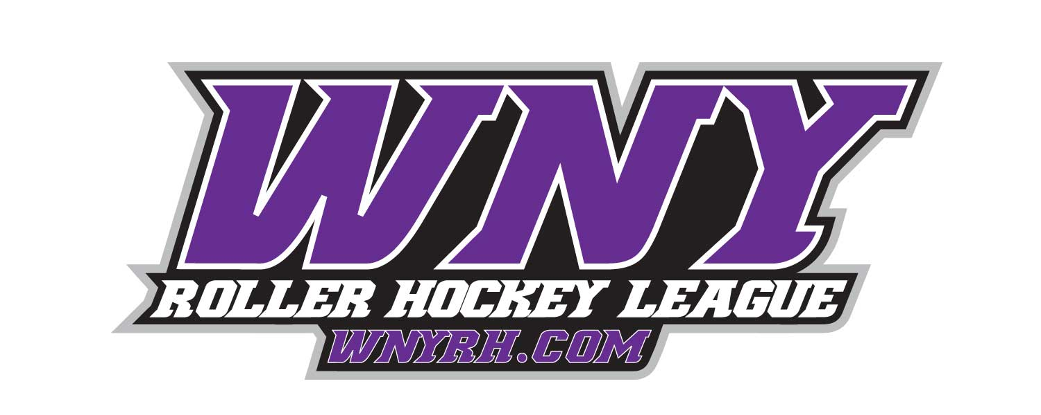
Fall 2019

Location: WNY Sports Arena, Tonawanda, New York
Game Play: 8 Games

Prizes: Team Awards to 1st and 2nd place finishing teams per division. Individual Awards for League MVP, Top Goaltender and Championship MVP will be handed out for each division.

Entry Fee: Adult League Pricing:
$115 per Skater if your roster size is 6 players
$100 per Skater if your roster size is 7 players
$90 per Skater if your roster size is 8 or 9 players
$70 per Skater if your roster size is 10 or more players
All Goalies - $50

- A $100 LATE FEE WILL ENSUE FOR REGISTRATIONS ACCEPTED AFTER Oct 4th, 2019.

Rules and Regulations:

- All players are required to possess WNY Roller Hockey Membership prior to the first game on week 1. Onsite registration and a $35 maintenance fee are mandatory at week 1.
- WNYRHL payment policy will be strictly enforced and ALL teams are to be paid in full by their 3rd game.
- All games will be played under WNYRHL rules.
- All Officials are certified by exam and seminar.
- Players can participate on 1 team per division, with the exception of goalies, who can be utilized as substitutes when needed.
- It is the responsibility of each team captain to have rosters confirmed prior to start of game 1. Team rosters must be finalized AND team fees paid in full prior to the start of game 4 in order to continue league participation. In the event a player provides partial payment then decides to forego the remainder of the season, it is the responsibility of the team captain and/or teammates to produce the remaining balance for the absent player. If for any reason a team fee is not paid in full by week 4, each week thereafter will be considered a forfeit loss until the remaining balance is rendered. Of note, substitute players will be able to be added once your team is paid in full, for a fee of $10.00 per game played, which is to be submitted prior to the start of the game. All substitute players must possess the WNYRHL Membership in qualify for game play.
- WNY Roller Hockey Staff has full authority to suspend a player, coach, or coaching staff member for any VERBAL or PHYSICAL abuse to any staff member, OFFICIAL, player, or team official.
- First Fighting Penalty – suspension will be determined by league director (minimum 3 games). Second Fighting Penalty – determined by League Director, which could result in expulsion from the league
- Coaches/Captains will receive notification following any incident resulting in a suspension. All sales are final; no refunds will be issued in the event a suspension is handed down or for any other reason.
- The referee fees will be turned into the REFEREE (NOT THE SCOREKEEPER) prior to each game.
- Each team will be required to wear matching jerseys.
- Player must wear the same jersey number for the entire season. If your # changes, please notify scorekeeper. If any player is caught swapping numbers to avoid the registration process, the team will forfeit their game and the players involved will be suspended.
- Any player that is on the team roster AND paid in full will be eligible for playoffs. If a rostered Goaltender is unable to play in their team’s playoff game, that team will be eligible to get a new goaltender at the approval of the WNYRHL. NO EXCEPTIONS!
- All players under 18 MUST wear full facial protection.
- Team coaches/captains are also responsible for locker rooms (clean-up after games and or any damages) – Locker Rooms will be checked following games before keys or drivers license are returned.
- Rescheduled game requests must be submitted and approved by Week 2. We will do our best but there is no guarantee that we will be able to reschedule a game.
- In the event a team has to forfeit a game, a WNYRHL staff member must be notified 48 hours prior to the start of the game, at which time a $50 administration fee will be issued. Should a team forfeit occur without any notice given, a $100 administration fee will be issued to the forfeiting team. The fee is required to be paid in full prior to the next scheduled game, or else another forfeit and subsequent administration fee will ensue. NO EXCEPTIONS!

Game Information:

- 2-3 minute warm-up before each game.
- 3 - 15 minute periods of running time will be played.
- If goal difference is 2 goals or less, the last 2 minutes of play are stop time.
- All games will be played with Rocket Pucks and ONLY game pucks will be provided. Warm up pucks will NOT be provided.
- If following regulation a tie ensues, a 2 minute 3on 3 sudden death overtime match up will follow. Should a winner still not be decided, we will proceed with a 3 man shoot out until a winner is declared. NO game will end in a tie.
- There will be a 30 second rest between periods.
- Regular season play will award 2 pts for a win and 0 pts for a loss; OT loss awards 1 pt.
- No one is allowed on player benches (except players and coaches) during games and warm-ups, including suspended players.
- All stats will be updated during your game on our website (wnyrh.com).

Team Name____________________________________________________________________

Team Captain (print)_____________________________________________________________

Team Captain (sign)_____________________________________________________________

Credit Card Number (used for forfeits) ________________________________________EXP_________



