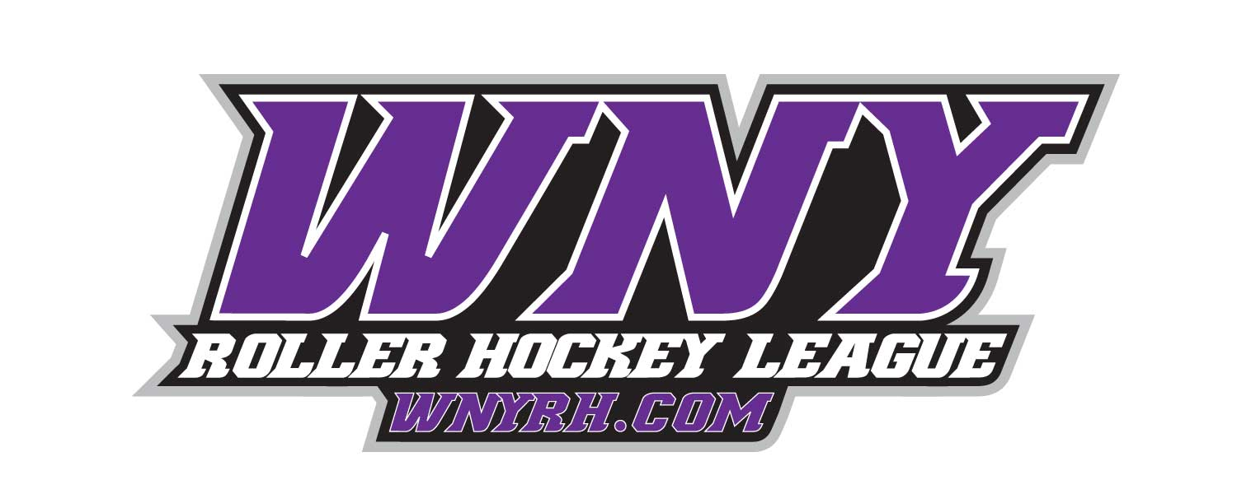

**2020 WNY Roller Hockey Official Team Entry Form**

**Please Mail Registration form to -**

WNY Roller Hockey #109 **Please Email Registration form to - Eric@wnyrh.com**

3843 Union Road Ste 15 **Contact** Eric Haak—716-903-2658

Cheektowaga, NY 14225-4248 OR Jason Flowers—716-444-2667 with questions

**Office Use Only:**

Down Payment (Captain must pay their fee in full): _____cash<> check<> credit______________________________________exp.____

3 Digit CVC________ Billing Zip Code____________

Jersey Number (amount): _____________

**TEAM’S FULL NAME:** ___________________________________

**Youth Division:** 22U____

**Adult Division:** Floor Hockey **_____**Aluminum (new) ____Copper ____Bronze ____Silver ____ Gold ____Iron **_____** 30 & Over (new) **____ DAY: ____________________**

**Contact’s NAME:** _______________________________________________

**HOME PHONE:** ___________________ **CELL PHONE:** _______________

**EMAIL (mandatory):** ____________________________________________

**Did your team play in our House League in Fall 19?** __________

Jan. 6th—2020 Winter Session Begins

**\*Kenan Center/WNY Sports Arena* \*\*\***

**WNY Roller Hockey League**